Question: What is the difference between “==” operator and “equals” method

Answer: “==” is meant for reference or reference comparison where “equals” method is meant for contents comparison.

For example:

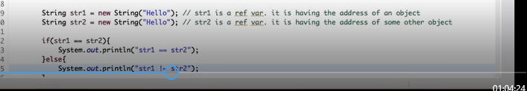

Output:

